San Francisco Parks

San Francisco offers a variety of parks and libraries, providing residents and visitors with opportunities for recreation, relaxation, and access to information. Here are some notable parks and libraries in San Francisco:
- Washington Square Park:
  - Location: North Beach
  - Description: Washington Square Park is a historic park in the heart of North Beach. It features a central lawn, playground, and benches, providing a relaxing space for locals and visitors. St. Peter and Paul Church overlook the park.
- Dolores Park:
  - Location: Mission District
  - Description: Dolores Park is a popular and vibrant park with expansive lawns, palm trees, and scenic views of the city. It's a social hub with picnic areas, sports facilities, and a playground.
- Alamo Square:
  - Location: Western Addition
  - Description: Alamo Square is known for its iconic row of Victorian and Edwardian houses, often referred to as the "Painted Ladies." The park offers a panoramic view of the city skyline.
- Golden Gate Park (Stow Lake and Spreckels Lake):
  - Location: Richmond District
  - Description: Golden Gate Park is one of the largest urban parks in the U.S., and within it, Stow Lake and Spreckels Lake offer tranquil settings for boating, walking, and enjoying nature.
- Bernal Heights Park:
  - Location: Bernal Heights
  - Description: Bernal Heights Park provides panoramic views of the city and Bay Area. It has open grassy areas, walking trails, and is a popular spot for dog owners.
- Buena Vista Park:
  - Location: Haight-Ashbury
  - Description: Buena Vista Park is San Francisco's oldest park, offering wooded trails, open meadows, and scenic vistas. It's a peaceful retreat in the heart of the city.
- Balboa Park:
  - Location: Outer Mission
  - Description: Balboa Park features sports facilities, a playground, and open spaces. The Balboa Park Pool and Balboa High School are located within the park.
- Candlestick Point State Recreation Area:
  - Location: Bayview-Hunters Point
  - Description: This waterfront park offers views of the bay, hiking trails, and picnic areas. It's a great place for outdoor activities and enjoying the natural surroundings.
- Noe Valley Courts:
  - Location: Noe Valley
  - Description: Noe Valley Courts is a neighborhood park with a playground, tennis courts, and a basketball court. It provides a family-friendly space for recreation.
- Corona Heights Park:
  - Location: Corona Heights
  - Description: Corona Heights Park offers stunning views of the city and features walking trails, a rock garden, and the Randall Museum, providing educational exhibits and programs.
- Presidio of San Francisco:
  - Description: The Presidio is a former military base turned national park with expansive green spaces, scenic overlooks, and historic sites. Crissy Field, the Main Parade Ground, and the Presidio Officers' Club are popular attractions. The newest attraction is Tunnel Top Park with expansion views of San Francisco Bay and the Golden Gate.

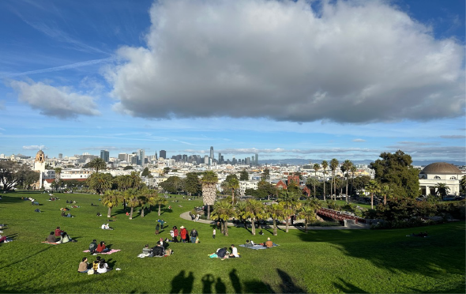 | 

